10 Ways to Prevent Back Injuries Handout
Directions: Compare your lists from class to these discussion points.

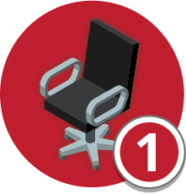 | Adjust your seat
 | Notes

Organize your workspace
Notes

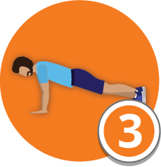 | Strengthen your core
 | Notes

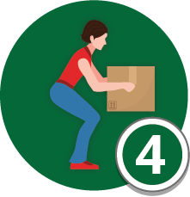 | Use proper lifting positions
 | Notes

Check your mattress
Notes

Use lifting equipment
Notes

Stretch, stretch, stretch (discuss exercises)
Notes

Be aware of slick surfaces
Notes

Wear personal protective equipment
Notes

Avoid same positions or uncomfortable movements
Notes

